CO1-AT2 : 2.5 TO 2.7
ITA0404-Statistics with R programming
Name : M.Akshaya
Reg no : 192320097

2.5 Missing Values

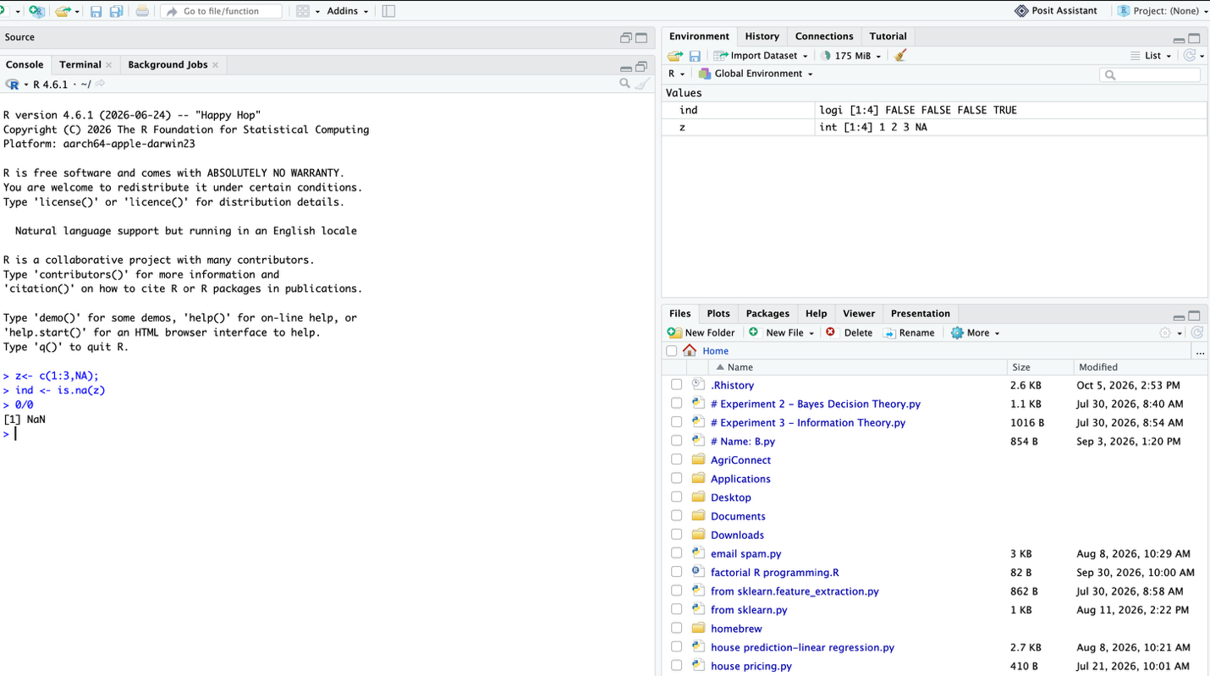

2.6 Character Vectors

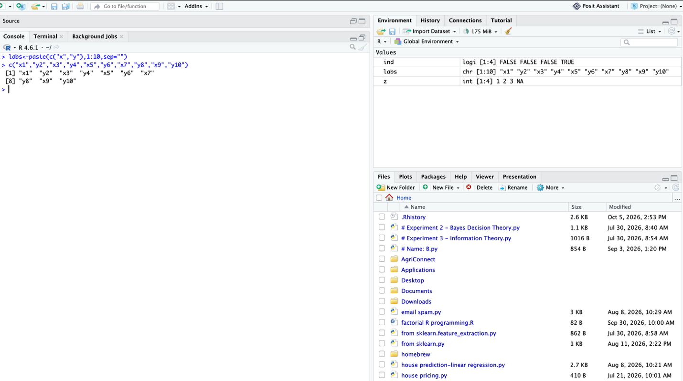
2.7 Index Vectors; Selecting and modifying subsets of a data set

